Comparison of 2 clips from 2 different horror films
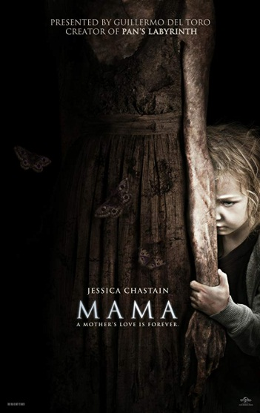
Clip one – Mama (2013) - https://youtu.be/o3w6MouV4NE
Sound
The music used at the beginning of the clip when the girl and man are walking through the forest is quite deep and eerie to make the scene tense. The music is typically found in horror films which helps the film live up to the horror genre.
There is also the sound of a wind chime as Dr Dreyfuss is walking through the forest. This means it is windy and It is also a creepy sound as it makes it tense as the audience may think someone is also there making them move as you do not see the wind chime in the clip, only hear it. The sound of the wind is an ambient sound. Both the wind and the wind chime are used to make a tense atmosphere and to set the scene by using the weather.
When the scene of the little girl comes on at 20 seconds in, the music is very quiet and almost stops as she calls out ‘mama’. We see the girl wondering around the back of a house in the dark, this can make the audience feel nervous as she is a young girl alone in the dark acting scared. Also, the girl then says, ‘where mama?’ in a sad voice because she wants mama. This can make the audience feel uncomfortable as usually smaller children would want their caring mothers, not scary ghosts. The little girl is used to make the audience feel nervous and worried.
The next part of the clip, the man (Dr Dreyfuss) is in the cabin and has spoken out to mama saying, ‘I know your name’. The sound the man makes is a loud, fast pant because he is scared because he knows mama is there and his torch has stopped working so he is in the dark. This would make the audience feel tense because they can hear mama but not see her so may be expecting her to jump out which fits the horror genre as a jump scare is a horror convention.
The sound that ‘mama’ makes is like a distressed animal, this is quite a loud sound which is shadowed by a deeper, angrier roaring sound when she attacks. This can make the audience jump as she is very loud when you least expect it, when the man reaches out to touch the wall. This helps identify that it is a horror film due to it having the jump scare convention. This is used to put the audience on the edge as they can hear ‘mama’ but not see her so do not know what will happen next.
Lighting
The lighting used throughout this clip is low-key lighting as it is set at night time.
At the beginning of the scene, the lighting used is low-key lighting as it is set at night time. The scene is dark with one little source of light which is Dr Dreyfuss’s torch light. This can impact the audience because the use of low-key lighting makes the figure stands out but not be clear to the audience which may be frightening. The use of the one torch light and darkness makes the audience feel isolated.
As Dr Dreyfuss Is walking through the forest, the only light is his torch light and also the light from the moon which is shown at the back of forest. This shows the silhouette of the trees which can be seen as a scary image as it only shows shadows and silhouettes. This can make the audience feel tense due to it being dark and you cannot see the setting clearly so anything could happen which could put the audience on edge.
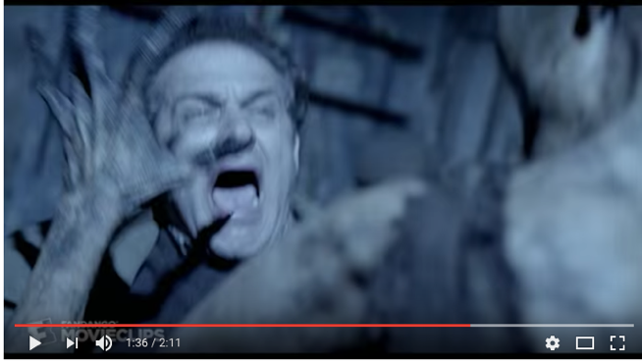
Further on towards the end of the clip, Dr Dreyfuss’s torch doesn’t work so uses a camera flash to see around the room. This flash shows the pictures taken from the camera and also mama coming out of a door way towards Dr Dreyfuss. This is used to scare the audience because you can hear mama even when the screen is black and you know she is getting closer, this can also result in a jump scare which is a horror film convention. The flashing lights can put the audience on edge as they don’t know what the next flash will show.
Camera techniques
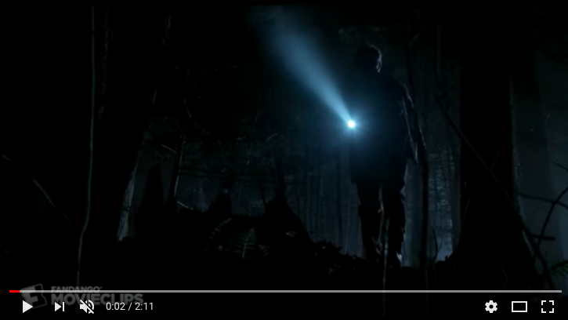
In this first shot, the character is shown using a long shot as you can see his whole body. It is also a low angle shot due to him being shown from beneath him. This impacts the audience as it shows them the whole setting so they can make their own judgements about what is going to happen. Also, it shows he has a position of authority in this scene. This then changes as the camera moves to an upwards pan which makes its way from the ground up to reveal Dr Dreyfuss, this is now a mid-shot of the character. This can also be an establishing shot to show a new setting and/or part of the story. The next scene he is seen walking which is a long-shot again as the camera tracks to the left to follow him.
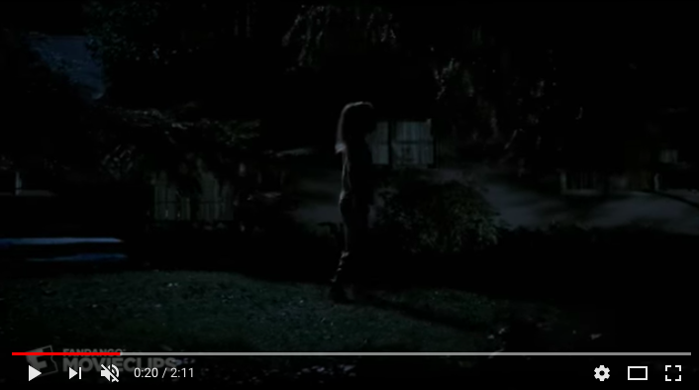
As Dr Dreyfuss walks towards the cabin, the camera zooms in slowly towards the door. This shows the audience what they should be focusing on in the shot, which is the cabin because that’s where he is about to go in. this helps put the audience on edge because they know he is going in there but they don’t 100% know what is in the cabin.
It then shows the little girl wondering around the back garden, the camera is used on a track to follow the girl, it is moving to the right on the track. This is used so the audience stays with the little girl whilst watching.
Once Dr Dreyfuss is in the cabin the camera is still in a corner of the room, but as he starts to walk more into the room the camera starts to pan downwards revealing more of the room and what he is doing as it starts to follow his torch light to the wall on the left.
As he is looking around the room, the camera follows the torch light along the wall, this is another tracking shot, it is tracked to the right and then the next shot is a mid-shot of the character with the light being tracked to the left.
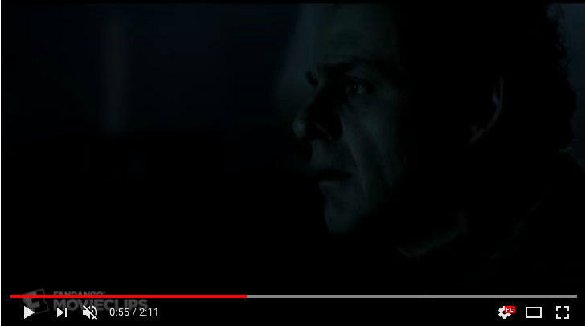
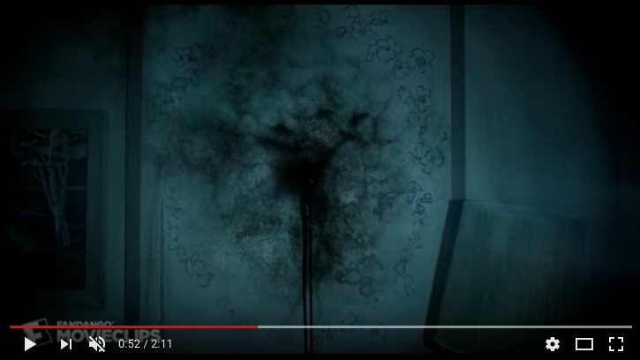
As Dr Dreyfuss finds the gungy black hole in the wall, the camera starts to slowly zoom in towards the wall. This could impact the audience as there could potentially be a jump scare as it is getting closer to the wall, this would make them tense and on edge. A jump scare is a horror film convention.
As he is looking at the wall, there is a close-up on his face. This shows the audience his facial expressions so they can understand how he is feeling being faced with that. This may change how they’re feeling whilst watching, due to seeing how he reacts. From his face, the camera then pans to the left which follows his arm down to his hand where he is reaching out. This could make the audience nervous as they know he is reaching towards the wall so they will not know what will happen.
As he is reaching out towards the wall, you first hear Mama’s wail which then takes Dr Dreyfuss’s attention away from the wall. This is shown by the camera then switching to a mid-shot of him to show him now looking into the room for Mama. The camera then tracks him to the right as he starts to walk into the room. This is used to follow the person so the audience can see what he is doing but not what he is walking into which creates tension.
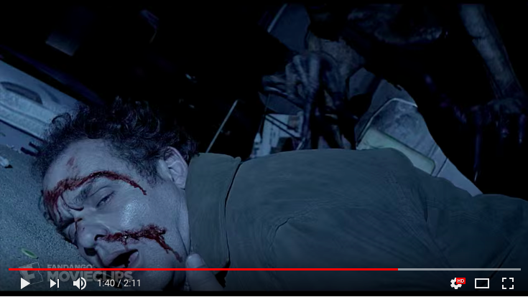
At the end of the clip, Dr Dreyfuss has been attacked by Mama and is now unconscious on the floor. The camera is on the floor along with the action which makes the audience feel like they are there are in the same position as Dr Dreyfuss.
Editing
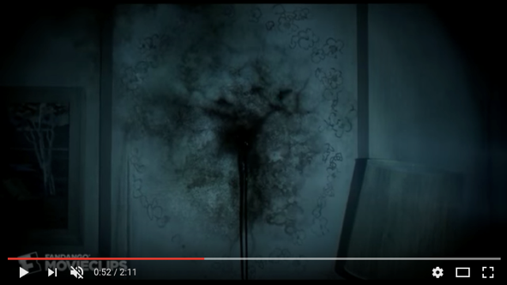
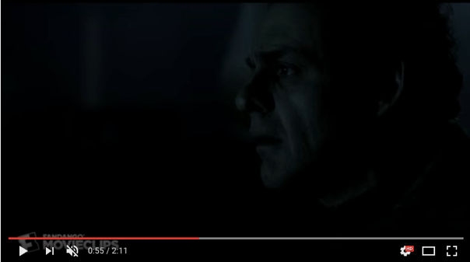
One editing technique used during this clip is an eye-line match. This is 2 shots edited together to show the audience what the character is looking at. This one involves Dr Dreyfuss with a confused look on his face which makes the audience think ‘what is he looking at?’ to then show them what he is looking at, which is the wall. This is used to make the audience tense.
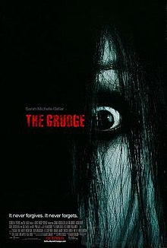
Clip two – The Grudge (2004) - https://youtu.be/uBAXDVB5Q6E
Sound
At the beginning of the clip, the music used is a drone sound as it is building up to something happening like a jump scare. This will impact the audience as they will expect something to jump out, but it is a false jump scare as it is only another character who is paralyzed by fear. The music stopped after this false scare to become quieter to allow the dialogue to be heard, to then be built up to the louder music to let the audience be aware something else is about to happen. This has been used to allow the audience to start feeling nervous again due to the louder, faster music being used. This is typical of a horror film as it builds up tension for the audience.
The next part of the clip shows a flashback of the murders of Kayako and Toshio by the Takeo (father/husband). The music in this part is the built up higher pitched music which then changes to a deeper, tense music as the husband emerges from a door dragging Kayako’s dead body. This could impact the audience as it could shock them as they see Kayako’s body. As the flashback continues, it shows the death of Toshio and the pet cat, the music has changed back to the higher pitched, faster music. This has been used to make the audience feel shocked and like they want to look away. This relates to the horror genre as it is scaring the audience.
After the scene of the flashback, you hear an ambient sound of a door slamming, this alerts the character that someone is there. The could make the audience jump as the doors slams which is a convention of the horror genre. This is used to make the audience know something is there and maybe coming but then again making them nervous as they do not 100% know something is coming. You then start to hear the croaking of Kayako, this dialogue shows she is coming down the stairs as you can hear her shuffling also.
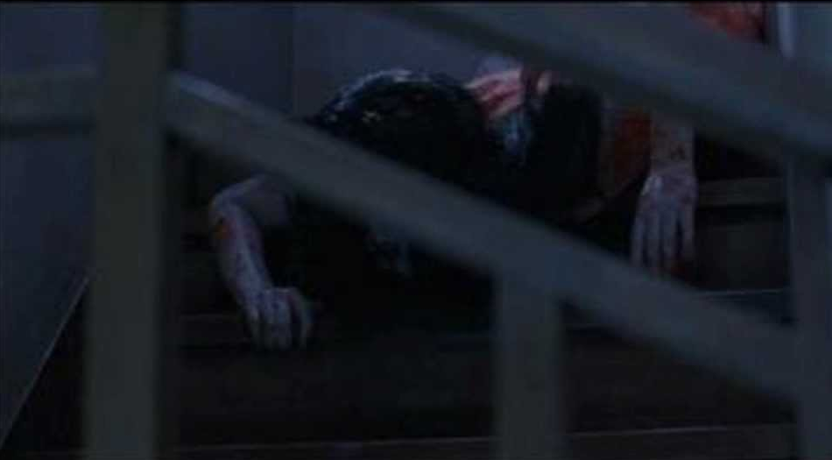
As Kayako starts to crawl down the stairs, she starts to do the croaking noise. This will impact the audience as it is a noise represented with ‘The Grudge’ so it sets them on edge as they know that Kayako is coming or is near. This shows it is a horror film as it lets the audience know something is about to happen by the noise but they don’t know what or when it will happen. The croaking noise can be described as dialogue as it is coming from Kayako.
You then continue to hear the croaking noise whenever Kayako is around. As Kayako crawls her way up Doug, he falls back and you hear a non-diegetic sound which sounds like his soul leaving his body as he has just died from fright. There is then a diegetic sound of a thud where he hits the floor. This shows the audience he is dead as he hits the ground with force. As Doug dies from fright, you hear the other character’s heart beat as she realises he is dead. This is a diegetic sound as it is happening to her. This is happening over Kayako’s croak. These sounds can impact the audience as it gives atmosphere to what is happening letting them know the characters are scared and they are dying. This shows it is a horror film due to the fast past sounds like the heartbeat.
After this part, Karen is the only character now alive so she is sat in the middle of the room looking around for Kayako. This is when you can hear different screams coming from around all around the house which freaks her out even more. this is a diegetic sound as it can be heard by the characters in the film. The screams can have an impact on the audience because they aren’t just coming from one direction, there are multiple screams from multiple directions which can distort the characters setting. As well as the screams, the furniture is also moving, banging and glass is smashing which again are other loud diegetic sound which again will distort the character. These sounds can be linked to a horror because they are loud and jumpy sounds which may make the audience jump or become nervous.
Lighting
The lighting throughout this clip is low-key lighting. This is to make it atmospheric and to create contrast between light and shadow.
The general lighting stays the same throughout the clip, low-key, dark and only the natural light from the outside. This makes an impact on the audience because you can’t see fully around the room which makes the audience nervous and tense.
Kayako has now been shown in the mirror as Karen walks past, so due to it being dark with only natural light makes the fact you know there may be a jump scare as you have just seen Kayako, which is a horror film convention, can make the audience feel tense.
The lighting stays the same throughout the clip due to maintaining the same context.
Camera techniques
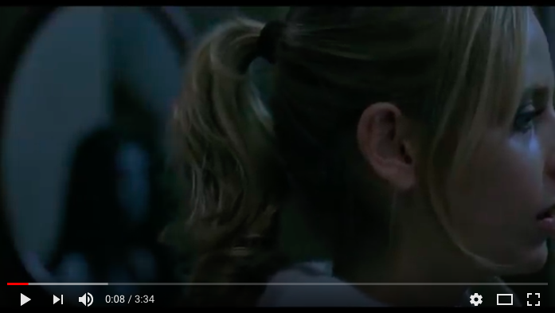
At the beginning of the clip as Karen has come down the stairs and walks past the mirror, the camera tracks with her head to show Kayako walk past the mirror behind her. This is to show that Kayako is there but Karen doesn’t know that only the audience does she it outs the audience on edge. This also is a close up as it is only showing Karen’s face. This can show the audience how she may be feeling by her facial expressions. This continues to show a close up of her face as she walks and looks into the mirror.
She is then scared by Doug as he crawls and grabs her foot, the camera then shows a close up of Doug’s face to show that he is paralysed due to shock and fear which indicates to the audience how he is feeling.
The camera then tilts upwards to move to the second floor of the house to then show the flashback. This tells the audience that something else is about to happen and it doesn’t involve Karen or Doug.
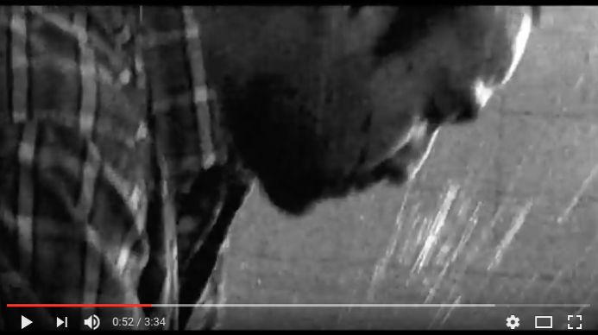
As the flashback is happening, there is another close up on Kayako’s face, this is used to scare the audience as they will see her face and realise she is dead and being dragged by her hair. This then changes to a mid-shot to show Takeo dragging her lifeless body down a corridor. This will creep the audience out as he has no emotion towards her whilst doing this.
There is also a close up on Takeo’s face as he is murdering the pet cat in the bath, this is used to show his emotions from his facial expressions.
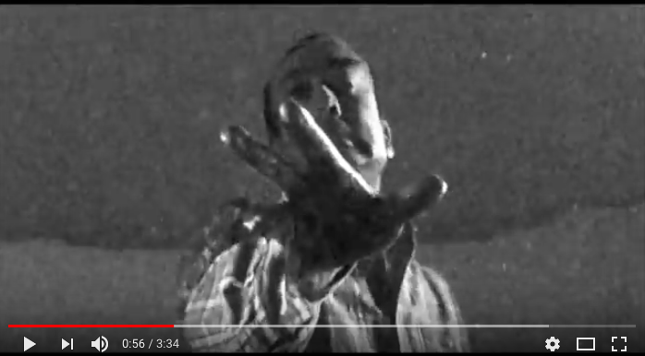
As Takeo is murdering Toshio in the bath, it shows a worms-eye view angle shot from Toshio’s perspective of being drowned with Takeo standing over him. This is also a point-of-view shot from Toshio as the audience are seeing out of his eyes. This makes the audience feel in the same position as Toshio making them feel certain ways just like the victim.
As well as this the camera angle then changes to a high angle of over Takeo’s shoulder of him drowning Toshio. This shows it now from Takeo’s perspective.
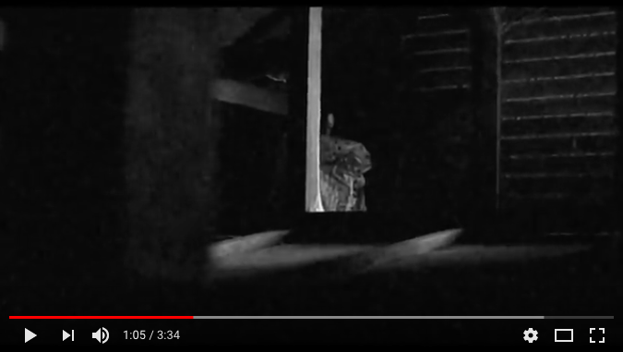
After this there is then a long-shot of the whole of Takeo dragging Kayako across a hallway into a room. This is used to show the actions of him and how he treats her, showing he doesn’t care because he is dragging her dead body by her hair. This could make the audience feel creeped out and maybe sad because he is taking no care with her.
The next camera angle is a point-of-view shot, this is from Peter’s point-of-view as he finds Kayako’s corpse. This is used to show the audience from a character’s perspective and also put them in his position of finding her body.
As Kayako starts to come down the stairs, the camera pans towards the stairs from Karen to show that is now the focus point as Kayako is coming. The camera also then has a close up on Kayako’s head as she jerks and cracks her neck. This could bring tension to the audience as they can see as well as hear her now so they will feel tense for Karen due to seeing Kayako coming.
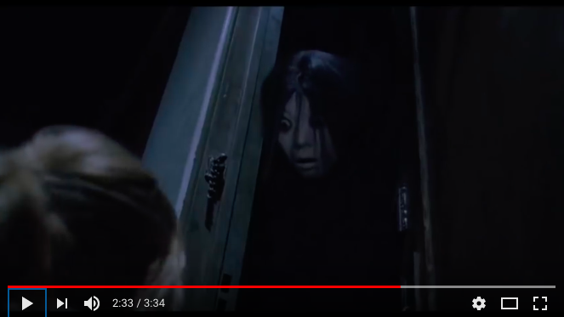
Once Kayako is down the stairs and has killed Doug, the camera does a close up on both Karen’s and Doug’s faces to show Karen’s fear and Doug staring at Karen as he has just died. This close up then shows Kayako’s hair then covering Doug’s face as she gets closer to his face. This is used to show more fear in Karen’s face as she knows she is now alone and also the creepy stare from Doug will make the audience tense. This will make the audience tense as Kayako has just killed Doug so they do not know if she will kill Karen also.
Another camera technique used is low-angle shot to show the power coming from Kayako. This lets the audience know Karen is in a low position compared to Kayako who has more authority as she is the one who will kill.
Editing
One major editing technique used is making the flashback of the deaths black and white. This adds context to the type of person Takeo is as he is murdering his wife and son with no emotion by the way he handles them. It is also used to let the audience know that it is a flashback and not actually happening in the present.
Comparison of the 2 clips
Lighting – The lighting used at the start of both clips is similar as each scene is in darkness. The clip from ‘Mama’ is darker as the emphasis of the torch light makes the background seem darker which makes figures and things such as the leaves moving stand out. This could impact the audience as it is good for the convention of jump scares because it is so dark and the focus is on the light. This is similar to the clip from ‘The Grudge’ because it is the dark but it makes shadows stand out to the audience such as seeing both the characters walking past the mirror, it made the ghost girl stand out and again could use the convention of jump scares from this. This can impact the audience by scaring them due to it being unexpected as you didn’t know when that could’ve happened. This is a jump scare which is a horror film convention.
Although there is also a difference due to there being no focus point (like the torch light) in this clip so all senses are heightened due to being able to see everything in the same light. This can impact the audience because they are being aware due to there being no light and the character of the blonde girl being jumpy. This could lead to jump scares which is a horror convention.
Sound – The sound used for both clips have some similarities as they are both horror films. One of these similarities is the volume of ‘Mama’ and Kayako’s known noises. These are both diegetic sounds as they can be heard by the characters in the scene.
One difference between the noises is the volume, Mama is very loud and scary whereas The Grudge is quieter and creepier. This shows the difference in the films as they are different sounds but similar as they are both ghosts and both have their own separate noise. These noises also let people know they are around or coming closer even if you can’t see them.
Setting – The one main difference between the 2 clips is Mama is mostly set outside in the forest at the beginning, whereas The Grudge is set inside a house the whole clip.
A similarity between the clip settings is they are both set at night time so are both in natural moon light instead of electrical lights which makes them both part of the horror film genre as the setting in the dark emphasises shadows and makes a tenser atmosphere for the audience.
Camera techniques – Both these clips use the same camera techniques as they are both horror films. These include close ups to show the characters emotions and facial expressions, low and high shots to show the characters positions. These are used to make the audience feel different types of ways due to how the characters look and feel.
Editing – The editing techniques used in both clips are different. This is because the grudge has a flashback scene which is black and white to show the time difference. Whereas mama is all in the present tense but editing is used to show characters perceptions. Although these are different they are both used to make the audience feel tense and scared which is why they fit into the horror genre.

